# Installation

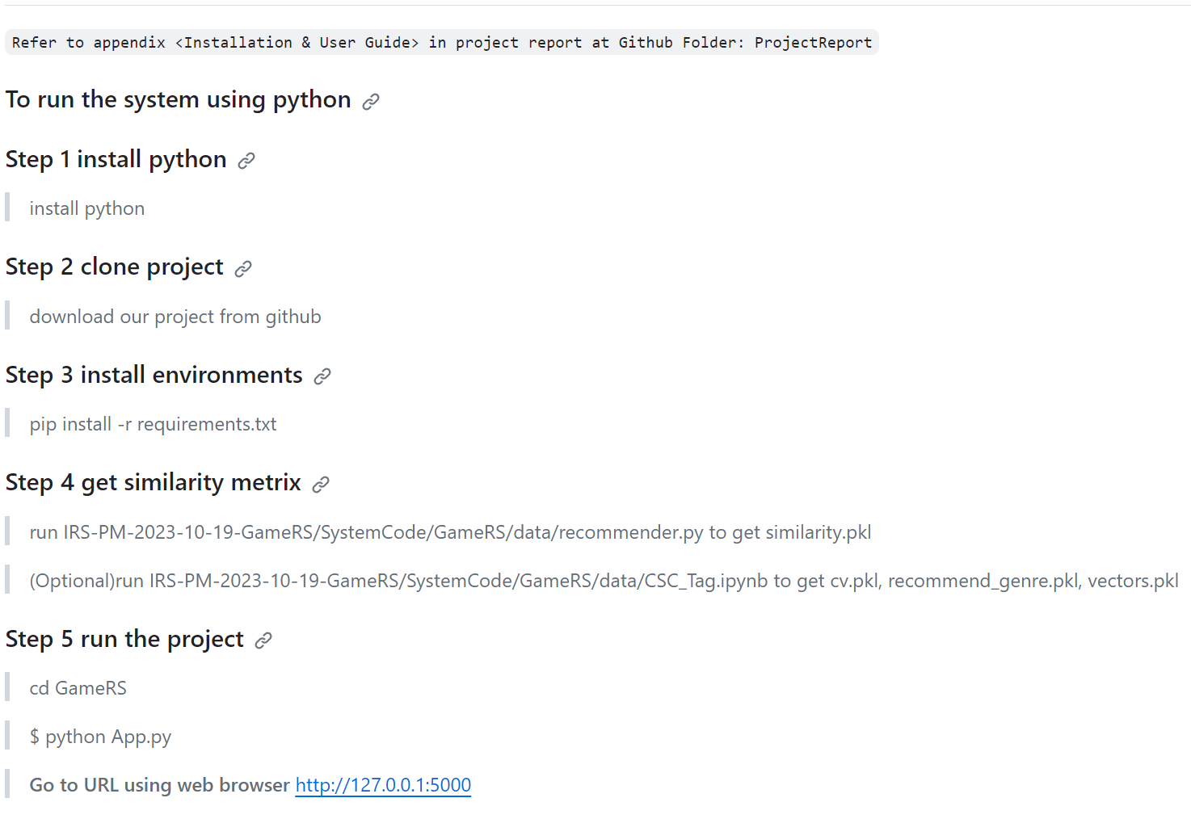

# User Guide

After installation, you will enter our website.

Firstly, you can register and login our website.

If you come the first time, after registration the system will automatically help you login.

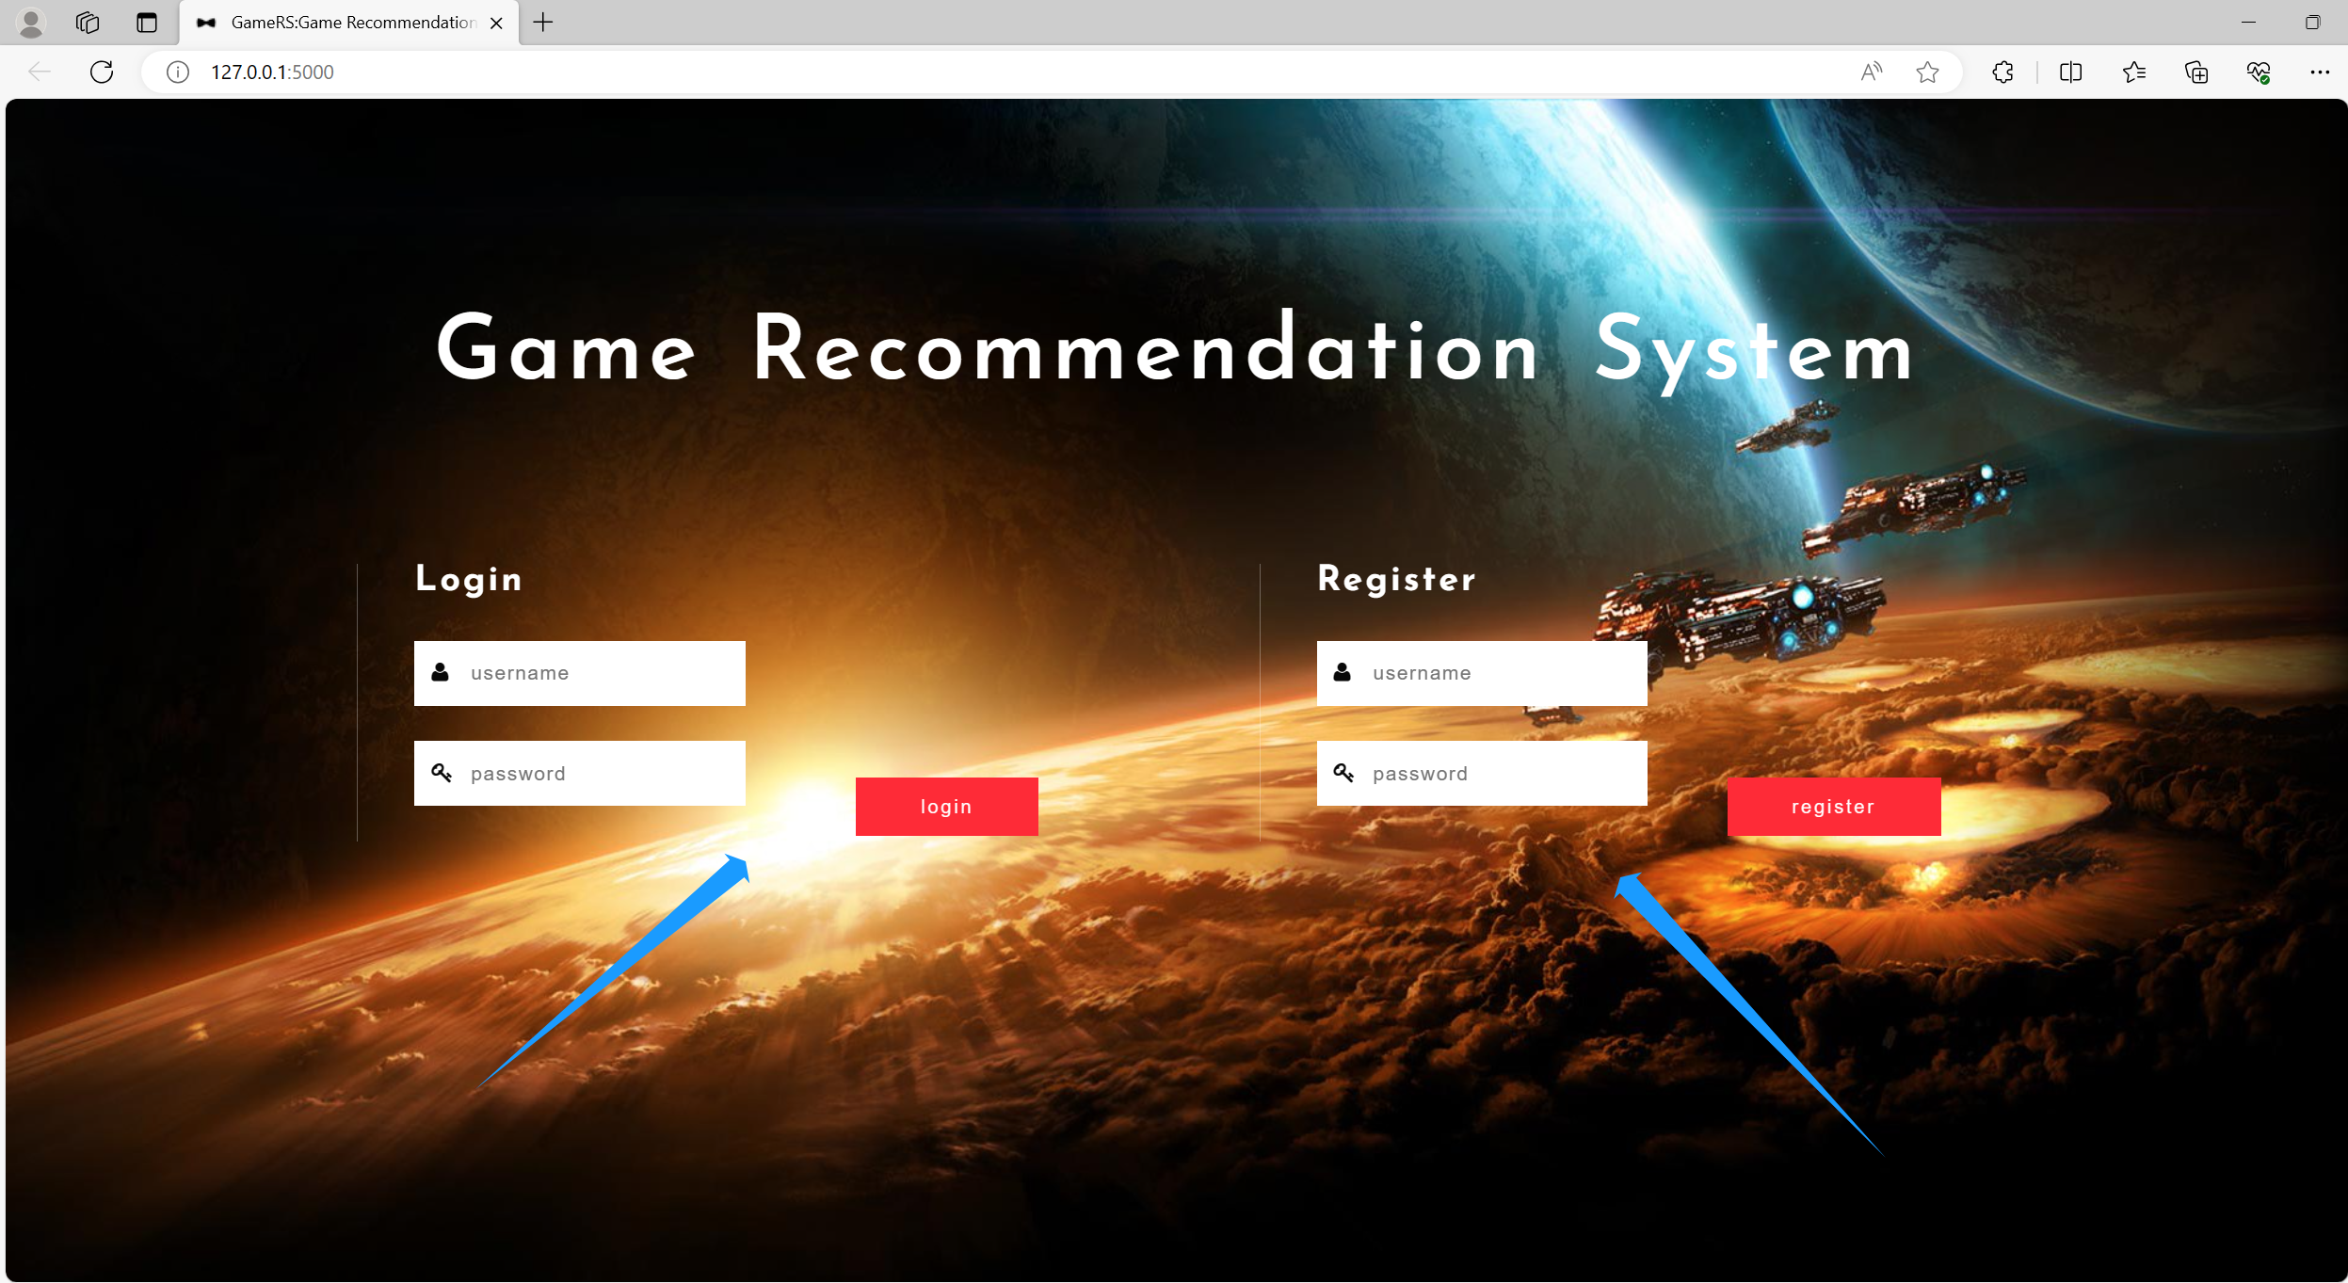

After login, you may see some up-to-date game industry information by charts.

Then you can click on the button in the red block to start with whatever function you want to use.

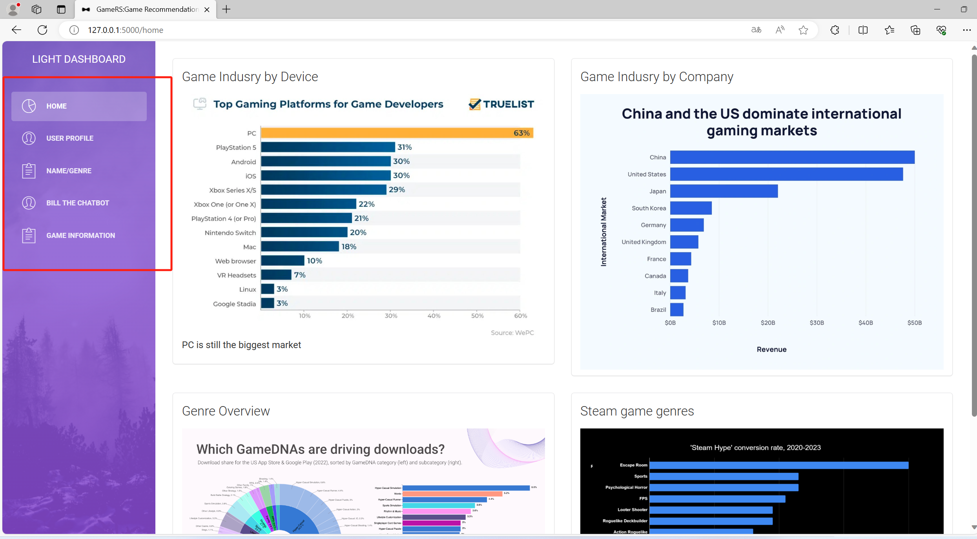

The user page is going to show some personal information, you can type and make adjustment whenever you want to.

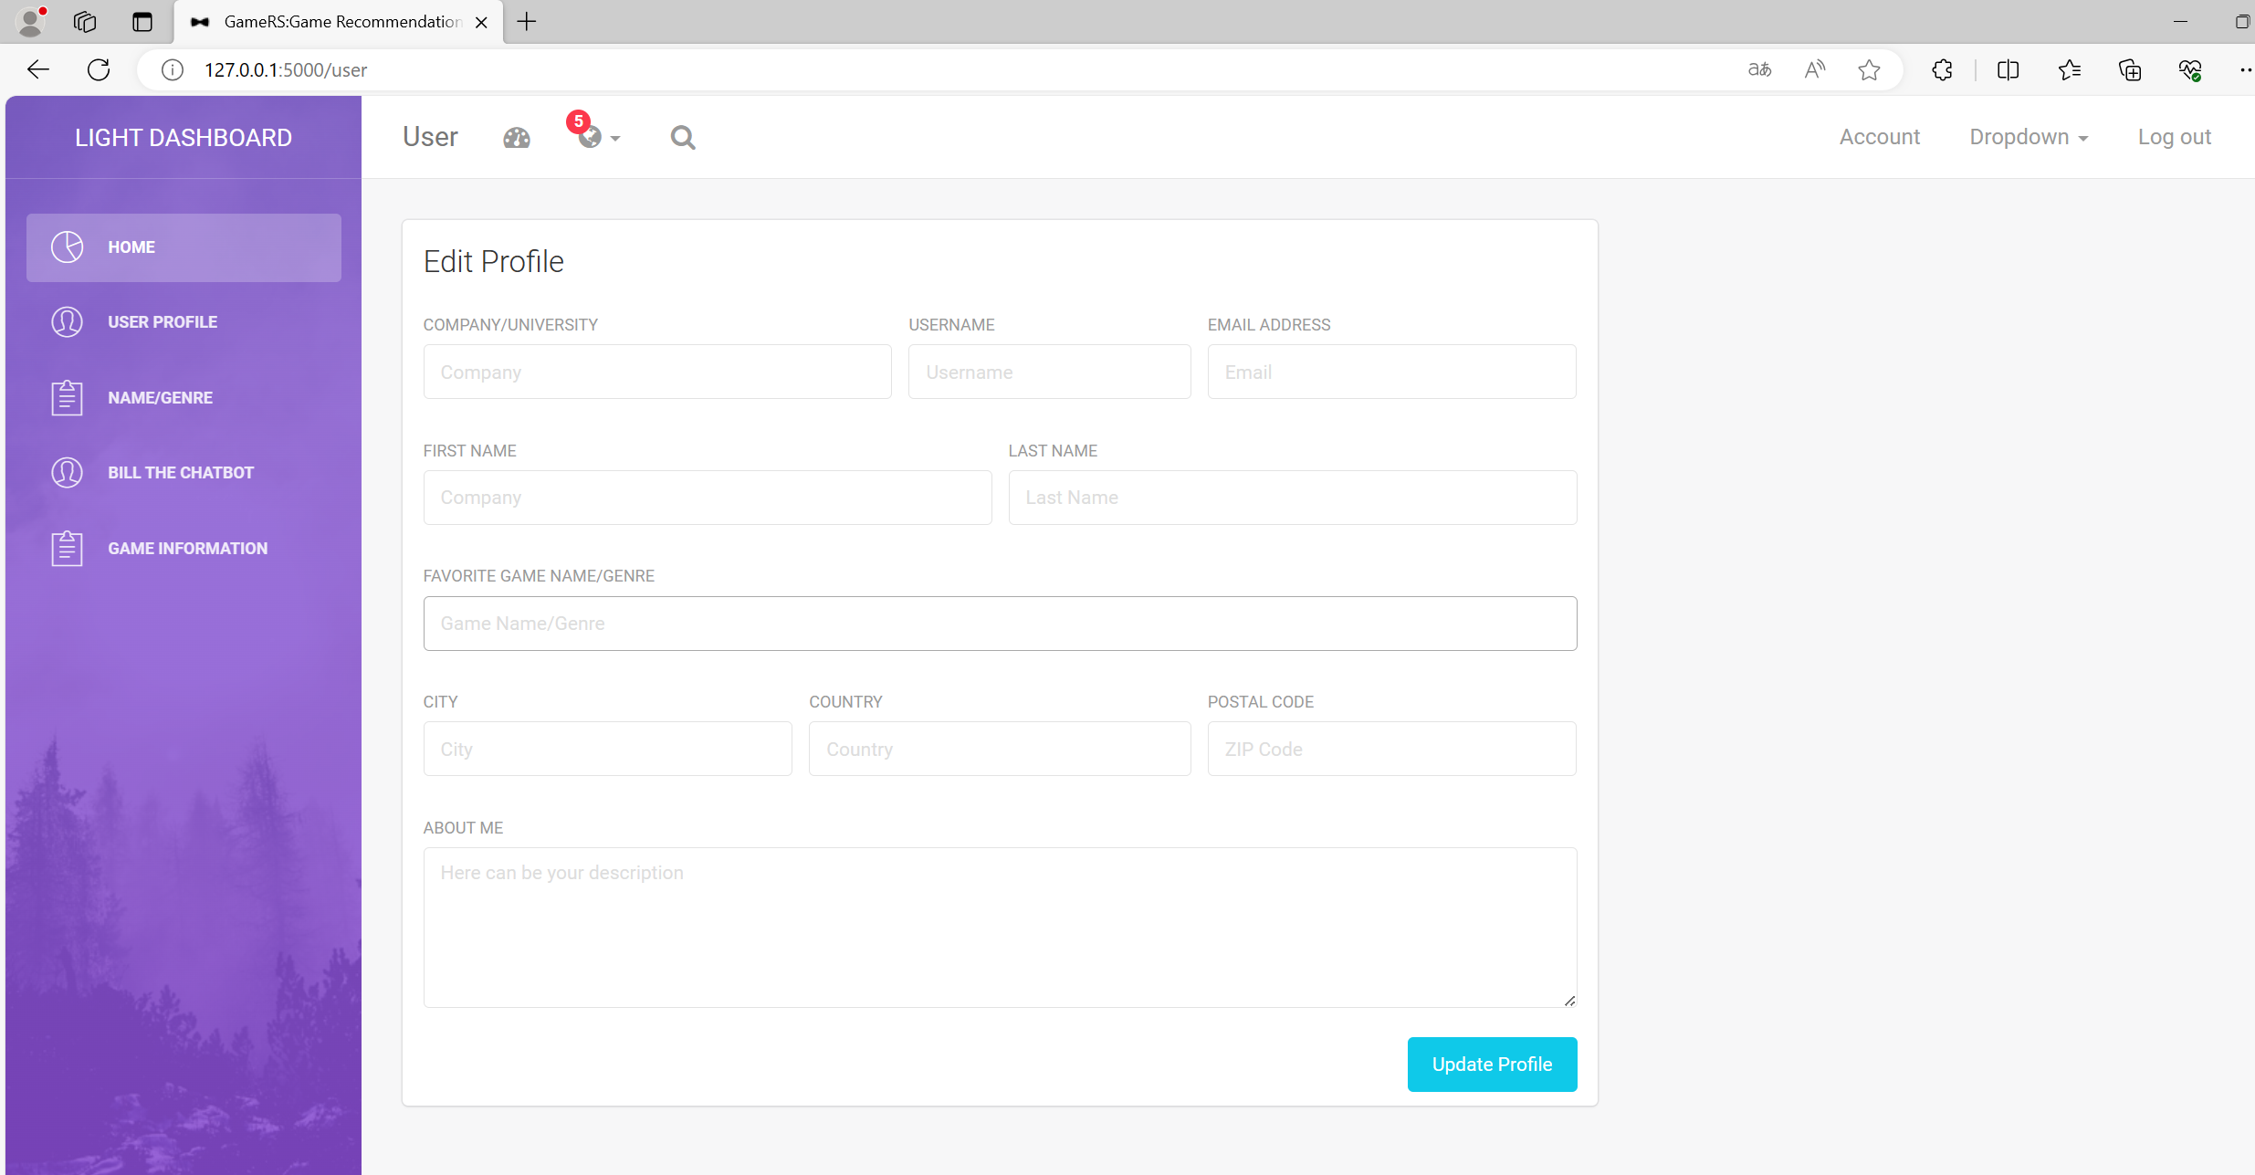

When you click on the GAME/GENRE, you will enter the recommend page.

This is our main function page, you can choose different information you want to search, game name or game genre, and click on the red button to generate.

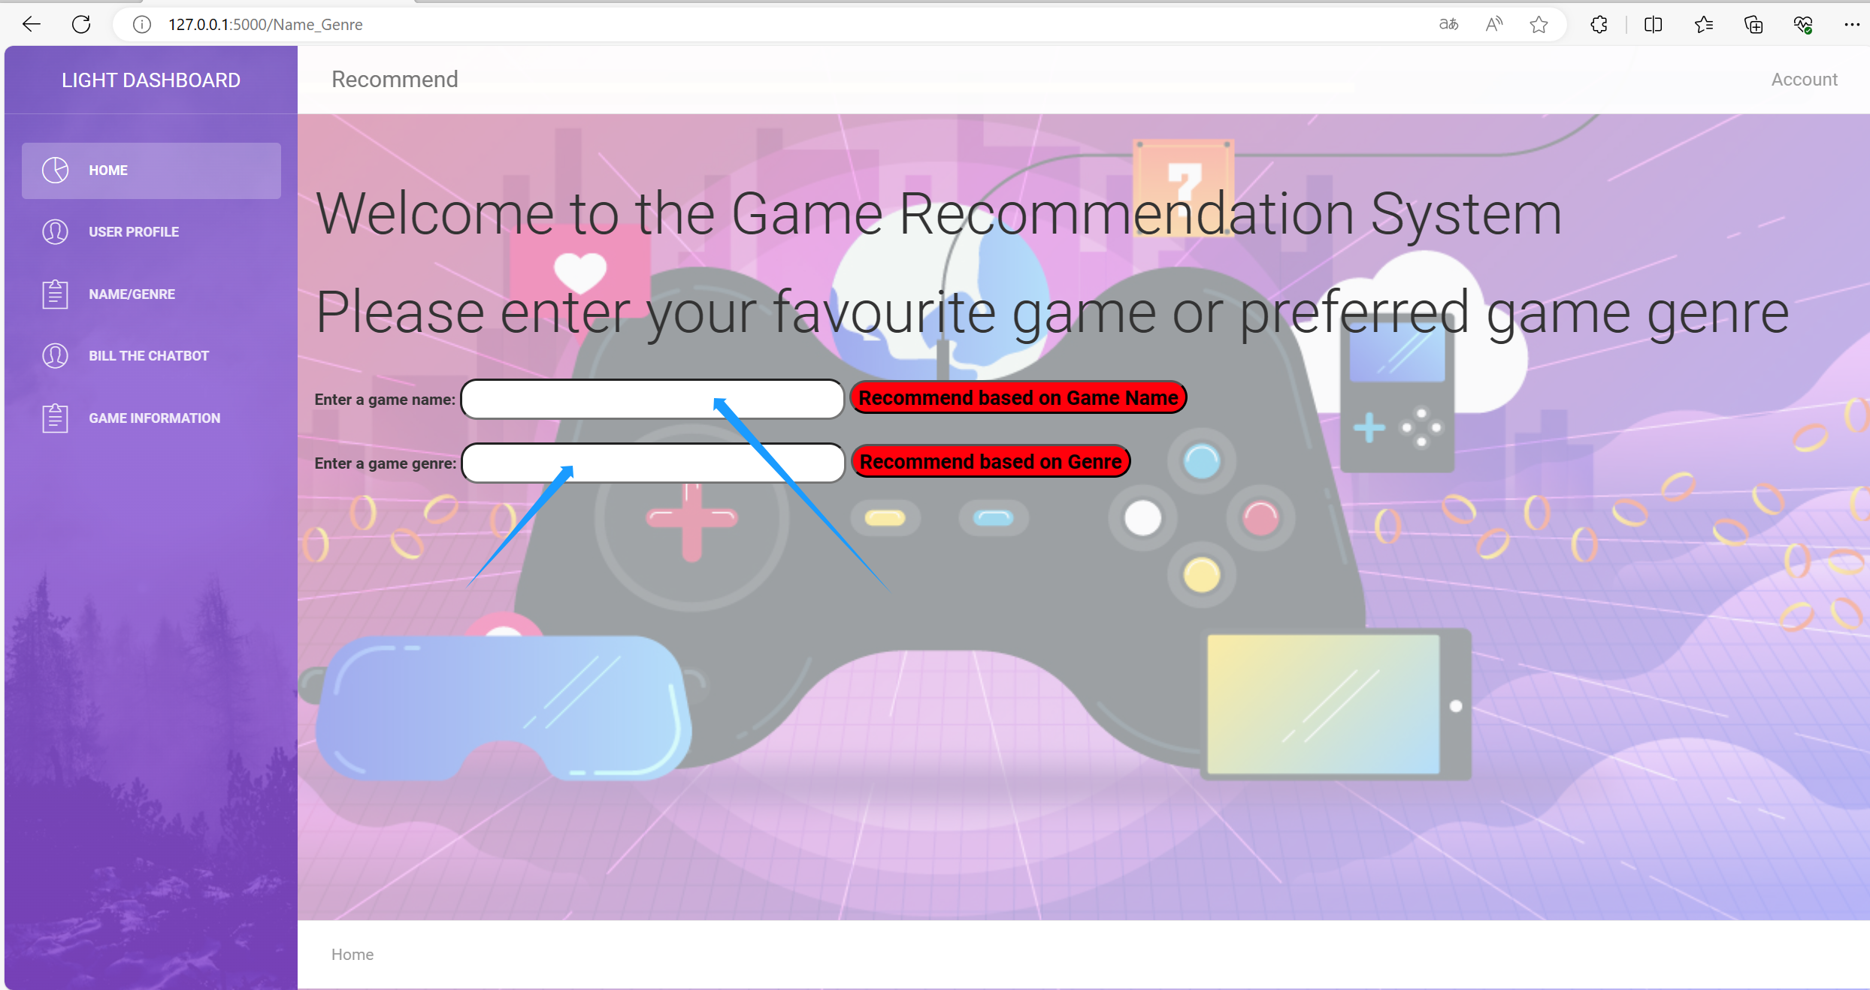

By the way, if you don’t know the exact game name, don’t worry! We have blur search!

You can just type the beginning letters or words, and click on the name you want to choose from the list to directly input the text.

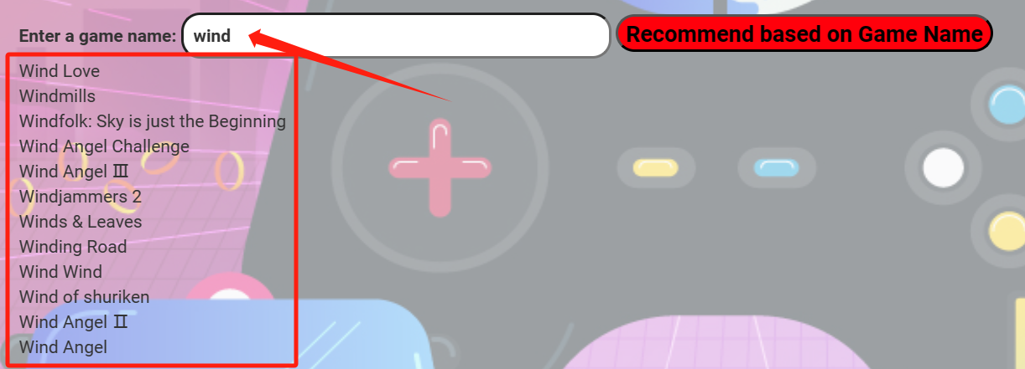

After click on the red ‘recommend’ button, you will get top-5 results like below.

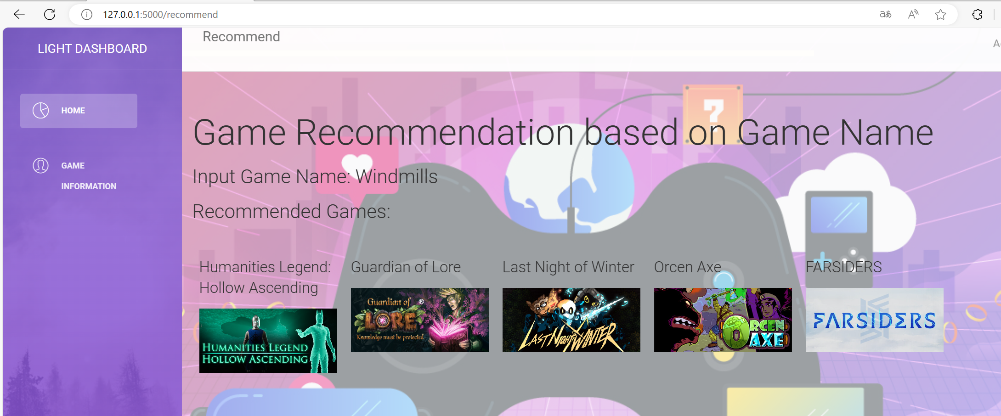

And when you go to the bottom of this page, you can see your search history in the form of bar chart and pie chart.

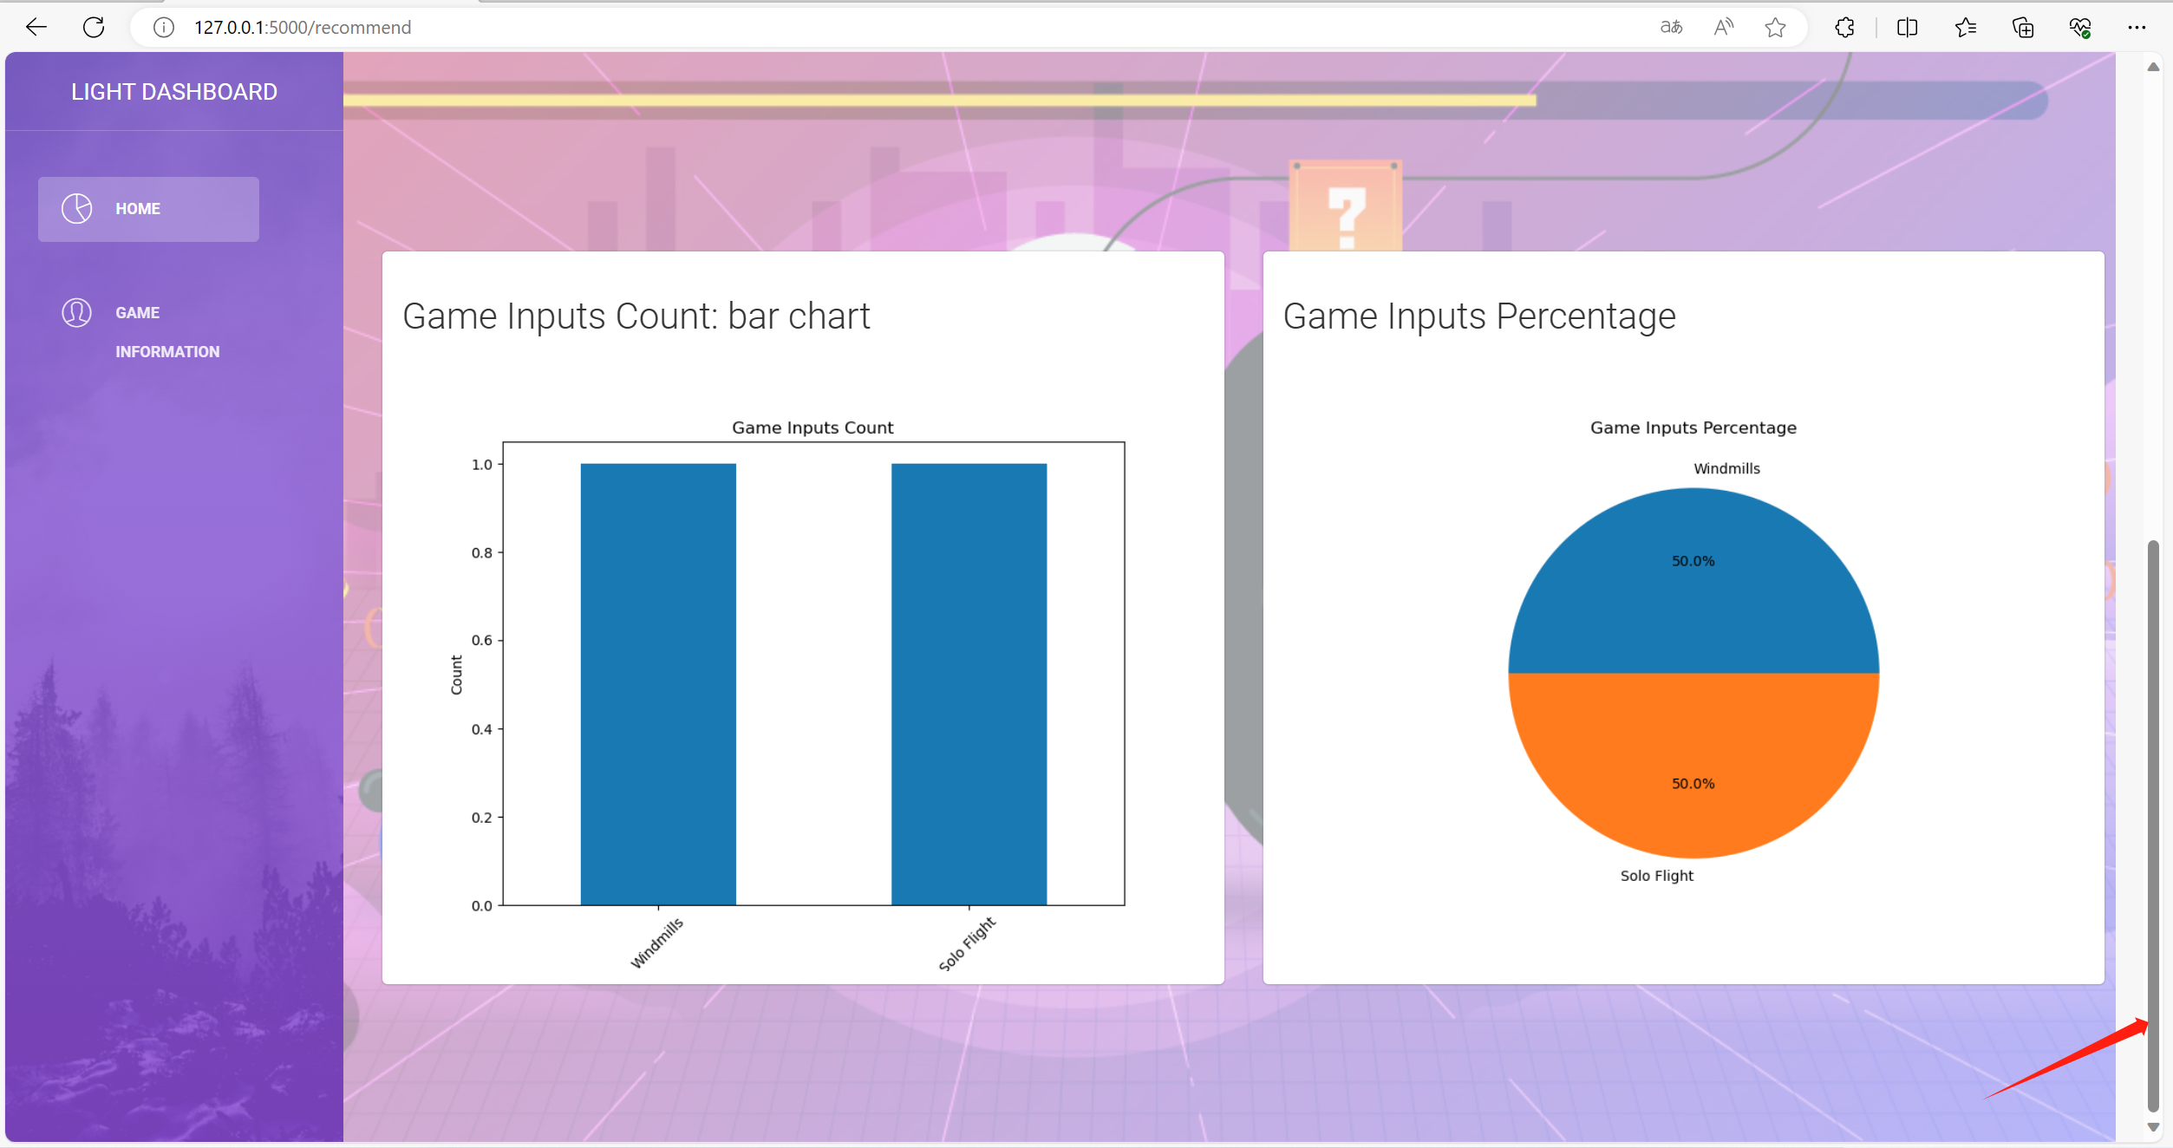

Game Genre is the same as Game Name, when you want to do so. You can have a try!

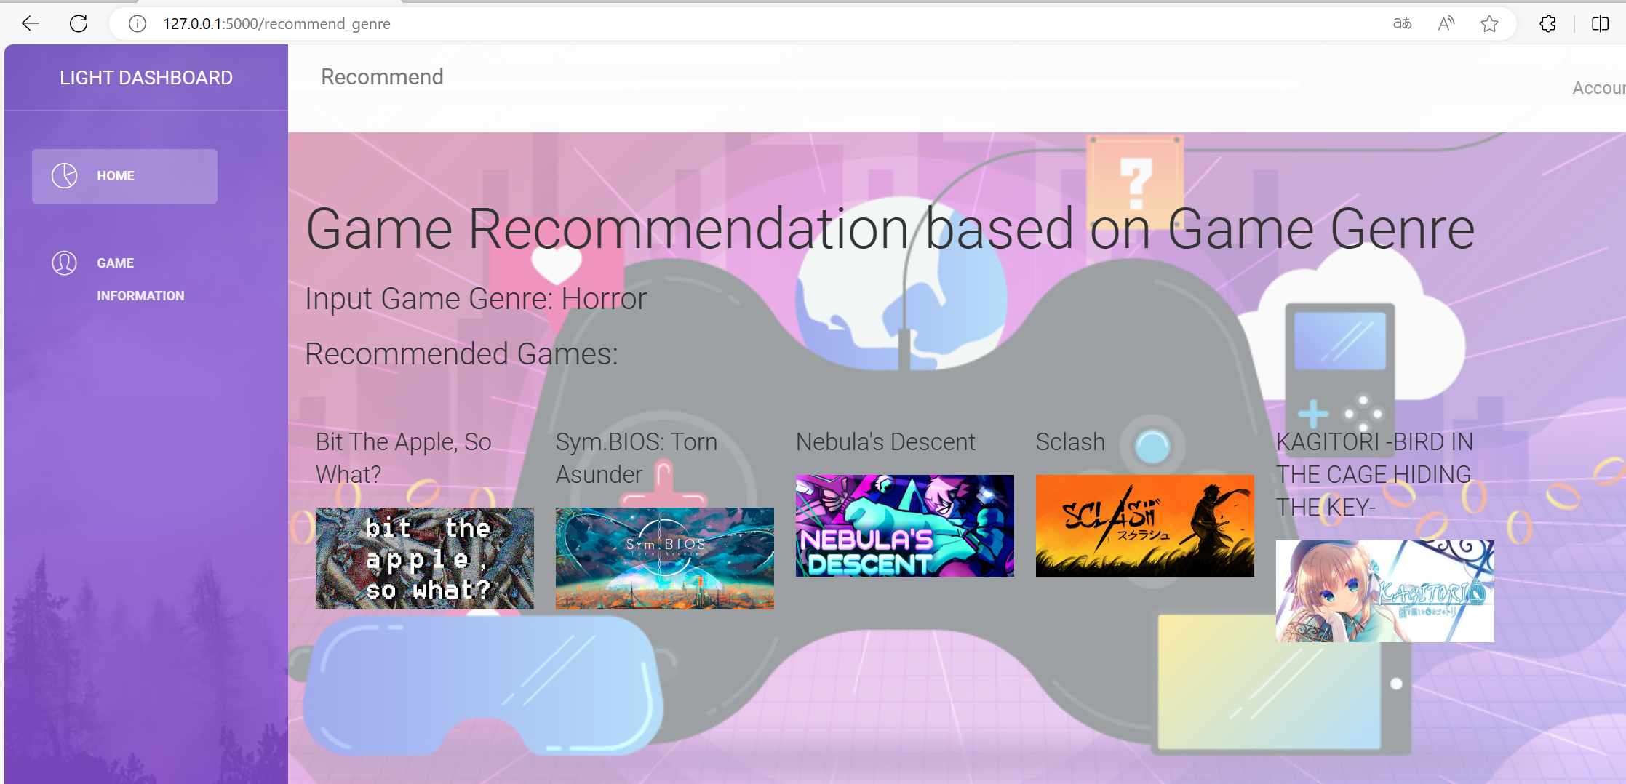

After the recommendation, you may want to know more about the game that recommended to you. Just click on the ‘GAME INFORMATION’ button on the dashboard list on the left and you will get into the information page.

Blur search is also available in this page to help you find and type!

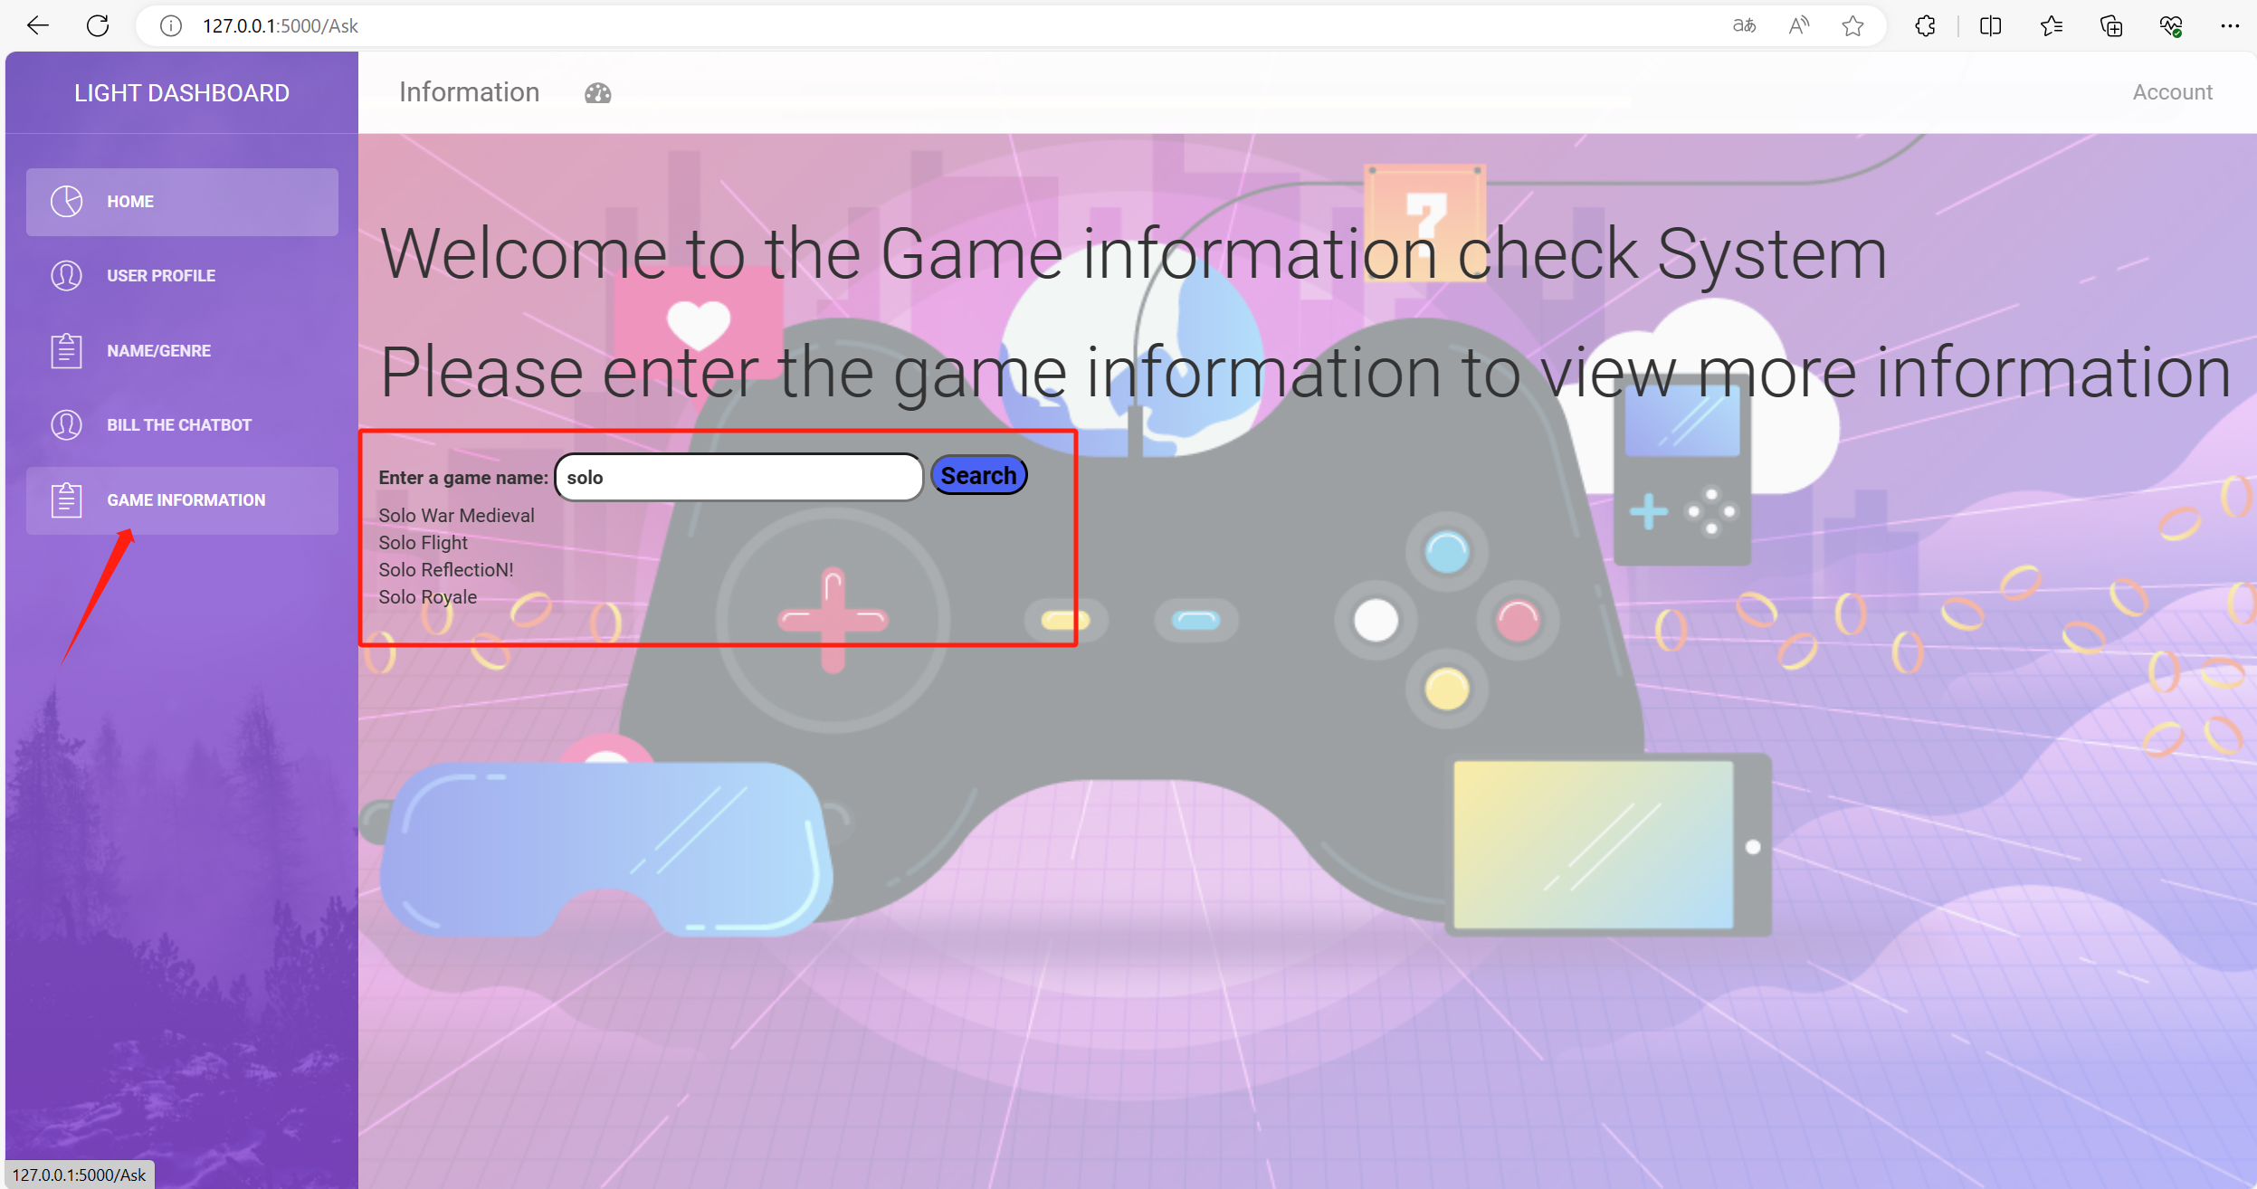

When you click on the ‘Search’ button, you will jump to the result page showing some information about the game.

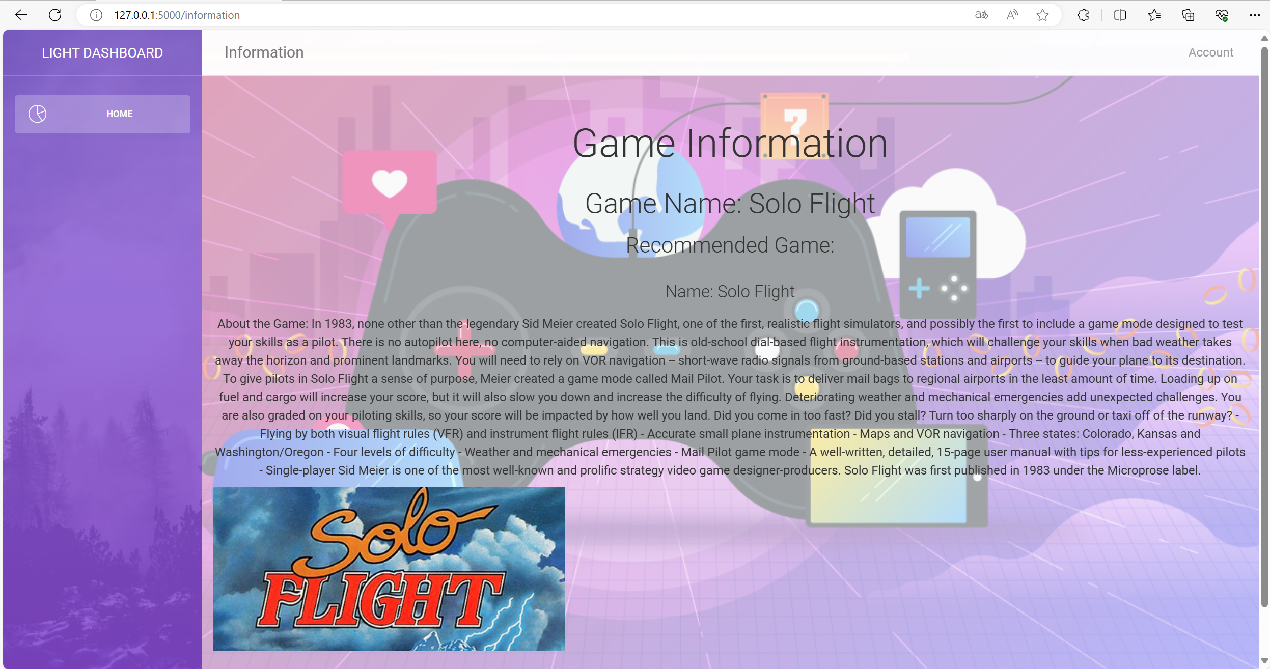

By the way, you can always click on the ‘HOME’ button on the dashboard list to return to homepage.

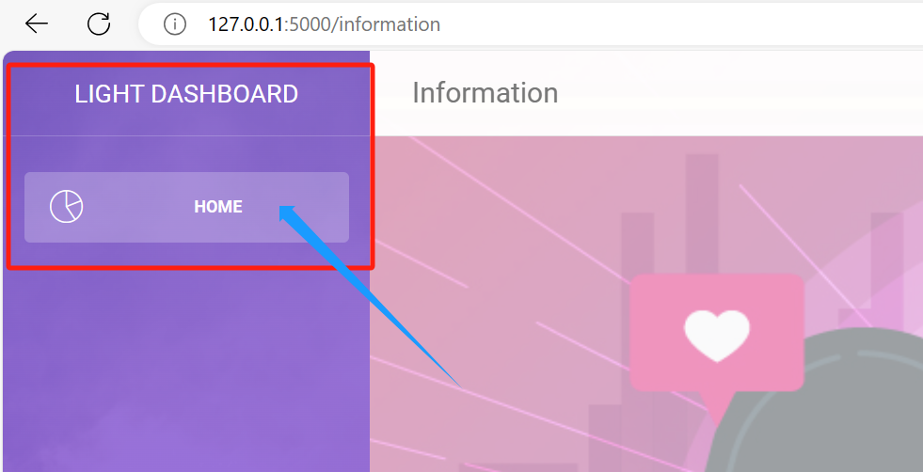

Last but not the least, we have the chatbot Bill.

You can reach it from the homepage by click on the ‘CHATBOT’ button.

Type whatever you want to ask and click on the ‘send’ button to start a chat with Bill!

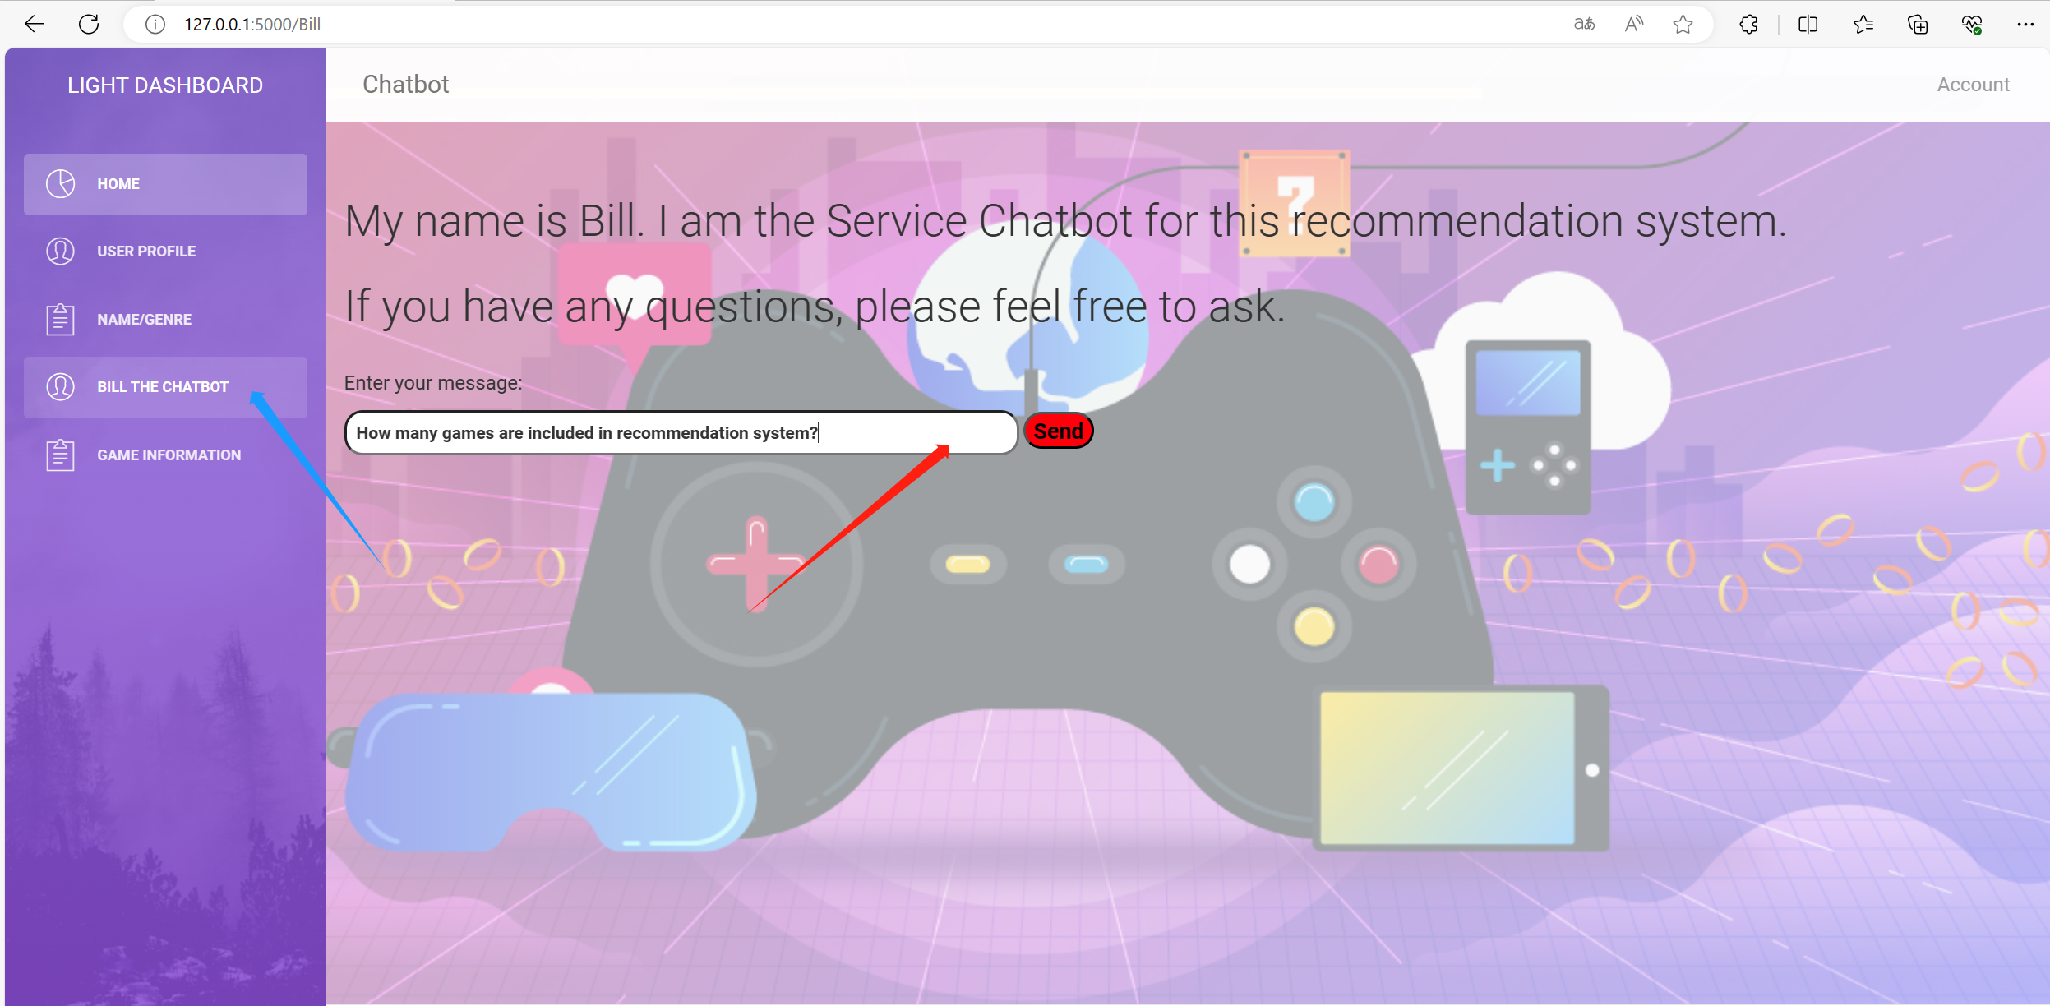

Bill can answer some basic FAQ knowledge about our system.

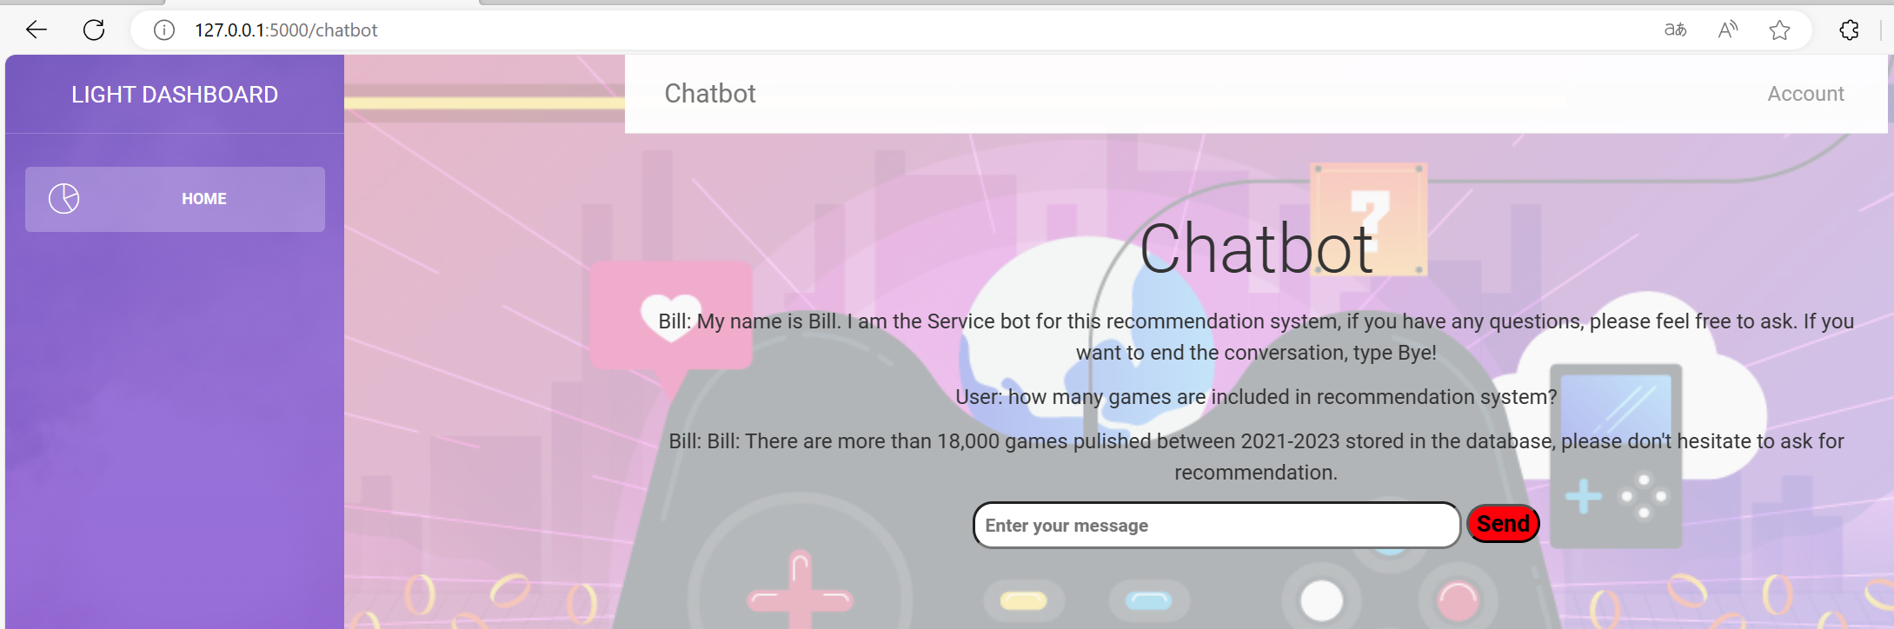

Bill can also help you with game recommendation!

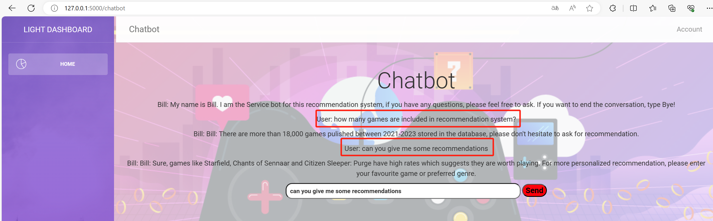

That’s all for GameRS. Hope you enjoy it!